**VS Code Link** - <https://code.visualstudio.com/download>

**Git Bash Link** - <https://git-scm.com/downloads>

**Zoom Link:** <https://zoom.us/download>

**MingW Compiler** - <https://drive.google.com/file/d/1aC9xQL2J1JSMT-ChEd2DP4OR4es5FSjq/view?usp=sharing>

**Settings.json** for windows- <https://docs.google.com/document/d/1cxFvTnr9TbuhRU7hthAVlhA928wybyYEQJOaBFKd_sc/edit?usp=sharing>

{

    "C_Cpp.default.cppStandard": "c++20",

    "C_Cpp.default.cStandard": "c11",

    "terminal.integrated.defaultProfile.windows": "Git Bash",

    "code-runner.runInTerminal": true,

    "code-runner.saveAllFilesBeforeRun": true,

    "code-runner.terminalRoot": "/",

    "code-runner.executorMapByGlob": {

        "pom.xml": "cd $dir && mvn clean package"

    },

    "code-runner.executorMap": {

        "javascript": "node",

        "java": "cd $dir && javac $fileName && java $fileNameWithoutExt",

        "zig": "zig run",

        "objective-c": "cd $dir && gcc -framework Cocoa $fileName -o $fileNameWithoutExt && $dir$fileNameWithoutExt",

        "php": "php",

        "python": "python -u",

        "perl": "perl",

        "perl6": "perl6",

        "ruby": "ruby",

        "go": "go run",

        "lua": "lua",

        "groovy": "groovy",

        "powershell": "powershell -ExecutionPolicy ByPass -File",

        "bat": "cmd /c",

        "shellscript": "bash",

        "fsharp": "fsi",

        "csharp": "scriptcs",

        "vbscript": "cscript //Nologo",

        "typescript": "ts-node",

        "coffeescript": "coffee",

        "scala": "scala",

        "swift": "swift",

        "julia": "julia",

        "crystal": "crystal",

        "ocaml": "ocaml",

        "r": "Rscript",

        "applescript": "osascript",

        "clojure": "lein exec",

        "haxe": "haxe --cwd $dirWithoutTrailingSlash --run $fileNameWithoutExt",

        "rust": "cd $dir && rustc $fileName && $dir$fileNameWithoutExt",

        "racket": "racket",

        "scheme": "csi -script",

        "ahk": "autohotkey",

        "autoit": "autoit3",

        "dart": "dart",

        "pascal": "cd $dir && fpc $fileName && $dir$fileNameWithoutExt",

        "d": "cd $dir && dmd $fileName && $dir$fileNameWithoutExt",

        "haskell": "runghc",

        "nim": "nim compile --verbosity:0 --hints:off --run",

        "lisp": "sbcl --script",

        "kit": "kitc --run",

        "v": "v run",

        "sass": "sass --style expanded",

        "scss": "scss --style expanded",

        "less": "cd $dir && lessc $fileName $fileNameWithoutExt.css",

        "FortranFreeForm": "cd $dir && gfortran $fileName -o $fileNameWithoutExt && $dir$fileNameWithoutExt",

        "fortran-modern": "cd $dir && gfortran $fileName -o $fileNameWithoutExt && $dir$fileNameWithoutExt",

        "fortran_fixed-form": "cd $dir && gfortran $fileName -o $fileNameWithoutExt && $dir$fileNameWithoutExt",

        "fortran": "cd $dir && gfortran $fileName -o $fileNameWithoutExt && $dir$fileNameWithoutExt",

        "sml": "cd $dir && sml $fileName",

        //WITHOUT TEXT FILE

        "c": "cd $dir && gcc $fileName -o $fileNameWithoutExt.exe && $dir$fileNameWithoutExt.exe",

        "cpp": "cd $dir && g++ $fileName -o $fileNameWithoutExt.exe && $dir$fileNameWithoutExt.exe",

        //WITH TEXT FILE

        // "c": "cd $dir && gcc $fileName -o $fileNameWithoutExt.exe && timeout 15s $dir$fileNameWithoutExt.exe < input.txt > output.txt || (echo -n > output.txt && echo 'Time Limit Gone')",

        // "cpp": "cd $dir && g++ $fileName -o $fileNameWithoutExt.exe && timeout 15s $dir$fileNameWithoutExt.exe < input.txt > output.txt || (echo -n > output.txt && echo 'Time Limit Gone')",

    },

    "window.zoomLevel": 1,

    "files.autoSave": "afterDelay",

}

**Setting.json for mac-**

<https://docs.google.com/document/d/1sbI7j9qRqCtVHmpBewzO613WjOiwE8Nh3QhNiGvn-64/edit?usp=sharing>

//code-1 => Paste it and run the code; you will see the result.

#include<stdio.h>

int main(){

printf("Hello world!");

return 0;

}

//code-2 => Paste it and run the code; take input, and then you will see the result

#include<stdio.h>

int main(){

int a;

scanf("%d",&a);

printf("a = %d",a);

return 0;

}

Shortcut Key:

| **Operation** | **Command** |
| --- | --- |
| Copy | Ctrl + C |
| Paste | Ctrl + V |
| All select | Ctrl + A |
| Command Prompt | + R,then type cmd → Press Enter |

Extension 1:

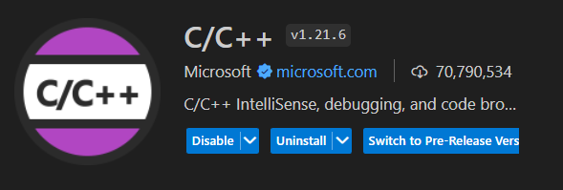

Extension 2:

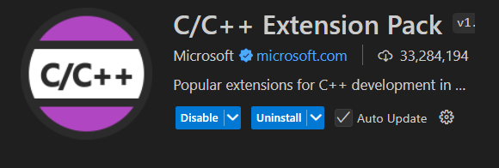

Extension 3:

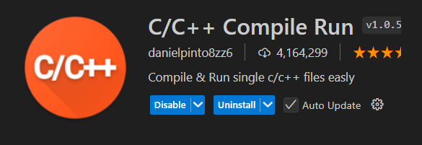

Extension 4:

